# Excel and Civic Data

This is the student’s guide for following the Excel and Civic Data workshop. It is modular, in that you can use each part independently. It is meant to be used along with the Excel files in this accompanying folder, but can also be used with any other open government data. It works best with data that includes location information, and some kind of date information (like an address and a completion date).

For this tutorial, you should use **Excel 2016 for Windows.** While most of this can be done in Excel 2013 for Windows, some of the menus and names have changed. Many of the tools are specific to Excel for Windows, so if you have attendees using a Mac, they should still use the Excel Windows version using either Basecamp or Parallels.

If you are using Excel 2013, you will want to [download](https://www.microsoft.com/en-us/download/details.aspx?id=39379&CorrelationId=10f925dd-f2f6-4f2c-8d0b-c9978aad50eb) [Power Query](https://support.office.com/en-us/article/Introduction-to-Microsoft-Power-Query-for-Excel-6E92E2F4-2079-4E1F-BAD5-89F6269CD605) to access the functionality discussed in this tutorial. You will need to [download](https://www.microsoft.com/en-us/download/details.aspx?id=38395) [Power Map](http://labs.office.com/guides/Creating%20Cinematic%203-D%20Data%20Stories%20with%20Power%20Map%20for%20Excel.htm) if you are using Excel 2013 to access the mapping functionality. Some of the new chart types are specific to Excel 2016. It is not recommended for versions earlier than Excel 2013.

The workshop is divided into the following sections:

* Accessing data
* Analyzing data
* Mapping data (Windows only)
* Transforming data
* Advanced analytics (an optional module)

Getting Stared

Excel is a tool that most people are familiar with, and many people use every day. Excel can be leveraged to unlock the value of open data of all kinds, and it is particularly well-suited to query and visualize open government data from multiple sources. In this tutorial, you will learn how to access, transform, cleanse, query, and visualize data using tools that are easy to learn and easy to use.

The scenario used here is Chicago's open data, and the files are located here: <https://doc.co/smWQbx>

Accessing Data Sources in Excel

*Open City Data Portal - at http://data.cityofchicago.org*

*Explore the interface of the data portal*

*Explore the categories and types of data (tables, maps, etc)*

*Click on Export and explore (and explain) the export options, and describe when to use what*

*Explore that it contains both datasets and maps. The maps can be downloaded and used later in the Mapping section*

*Open the Employee Salary dataset called the Current Employee Names, Salaries, and Position Titles data set.*

*Open the Export field and scroll down to and open the oData box.*

*Now we are going to look at the data connection wizard for oData feeds*

*Select and copy the oData URL*

*On the Data Tab, note the buttons on the Get External Data section.*

*Click on the From Other Sources arrow and choose "From oData Data Feed"*

*Paste the URL into the Link or File box*

Machine generated alternative text:
Data Connection Wizard 
Connect to a Data Feed 
Enter the information required to connect to a data feed. 
I. Location of the data feed 
Link or File: 
2. Log on credentials 
@ use the sign-in information for the person opening this file 
arm,vse... 
C) use this name and password 
user Name: 
Password: 
Cancel 
Back 
Next > 

*Click on Next*

*Click on the only table there*

*Click Finish*

Machine generated alternative text:
Import Data 
Select hcn,v you want to view this data in your workbook. 
@Table 
C) PivotTable Report 
C) PivotChart 
C) Power View Report 
C) Only Create Connection 
Where do you want to put the data? 
@ Existing worksheet: 
C) New worksheet 
Add this data to the Data Model 
Pcoperties... 
Cancel 

*Click OK*

Web Data

Here we are going to take data from a Wikipedia page and connect the tables it contains into Excel automatically.

*Explore the Wikipedia page: https://en.wikipedia.org/wiki/List\_of\_neighborhoods\_in\_Chicago*

*Click on the Data tab on the ribbon*

*Under the Get External Data section, click New Query and on from other sources*

*Choose From Web*

*For the URL, give it the same URL as the web page you opened (*[*https://en.wikipedia.org/wiki/List\_of\_neighborhoods\_in\_Chicago*](https://en.wikipedia.org/wiki/List_of_neighborhoods_in_Chicago)*)*

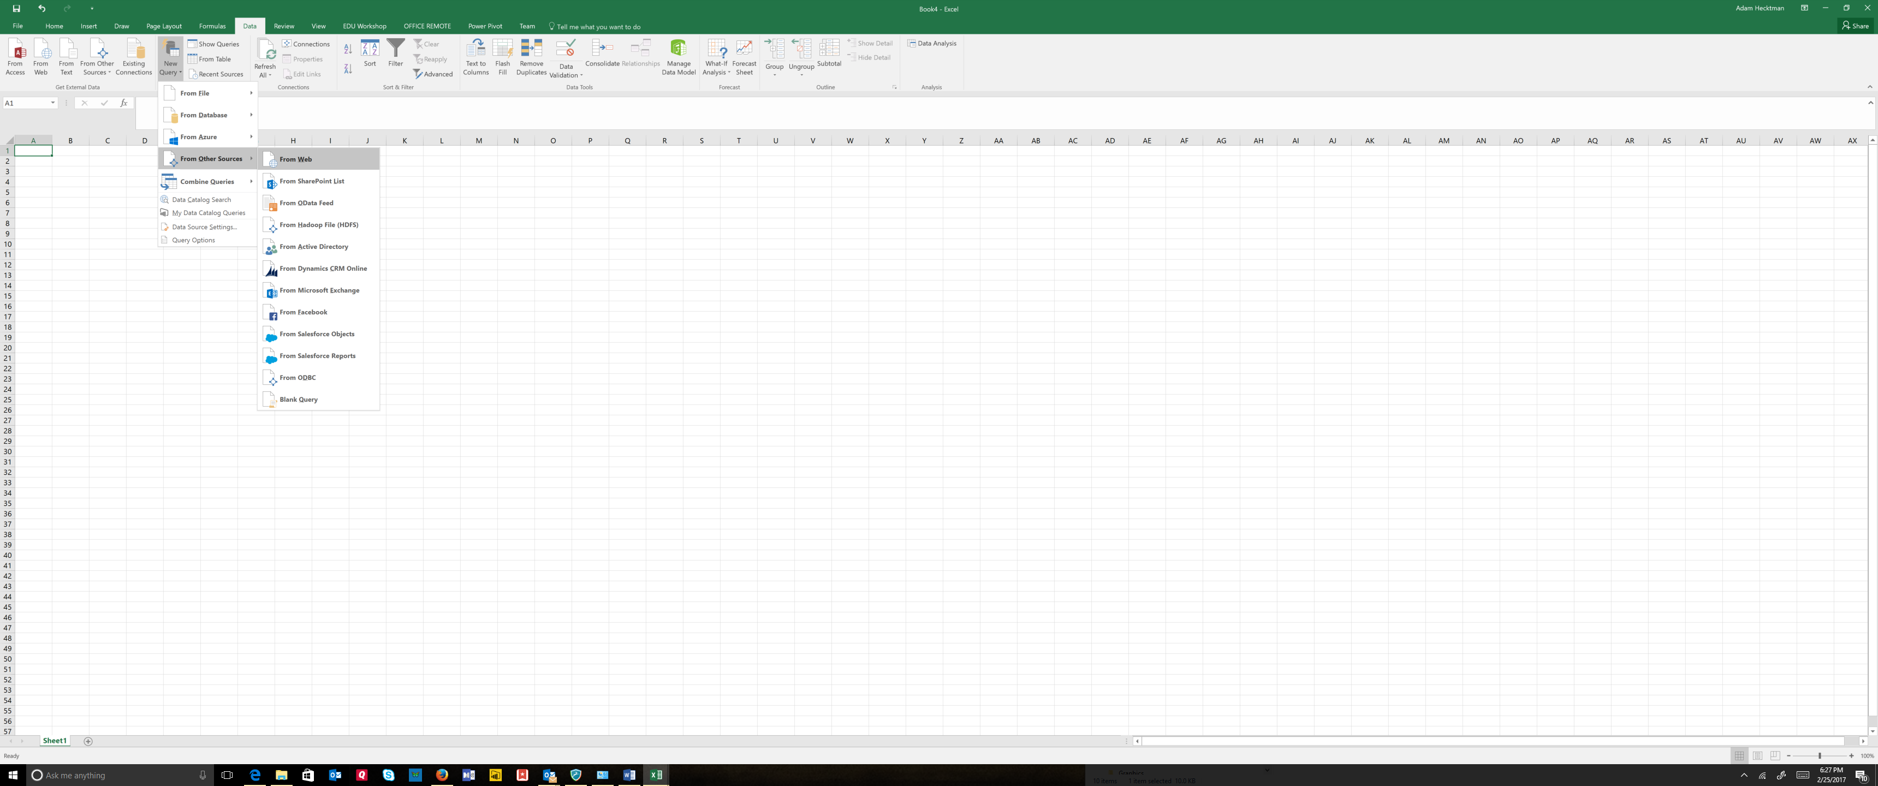

*Choose the List of Neighborhoods…table and click on the Load button*

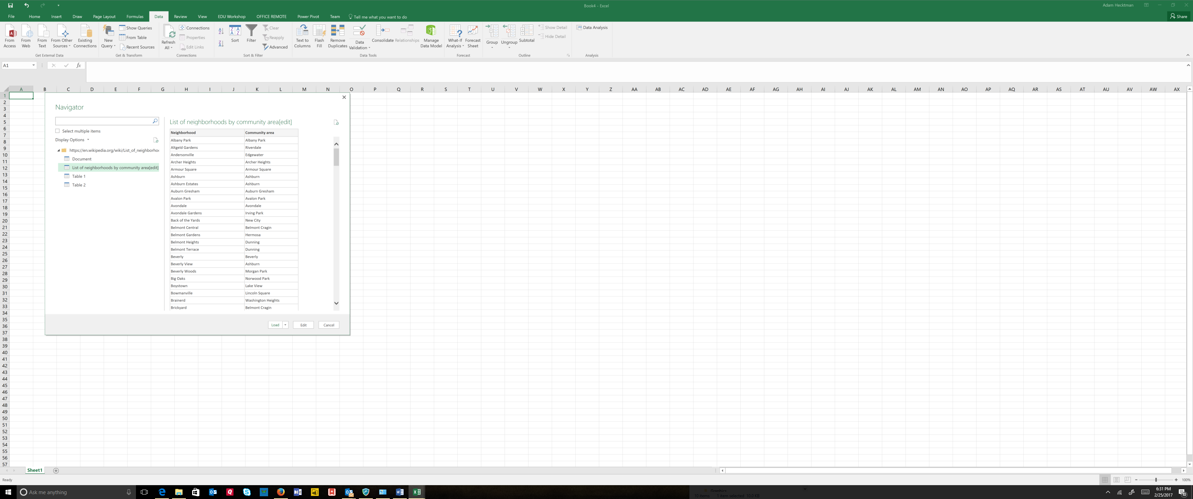

*Click on the filter arrow next to Community Area*

*Start typing Lakeview*

*Note that eight neighborhoods show up*

*Clear the filter*

*Creating Pivot Tables*

*Click inside the table*

*Click Pivot Table from the Insert Tab (in the Tables section)*

*We will use the defaults, so choose OK*

*Drag Community Area to Rows, and Neighborhood below Community Area*

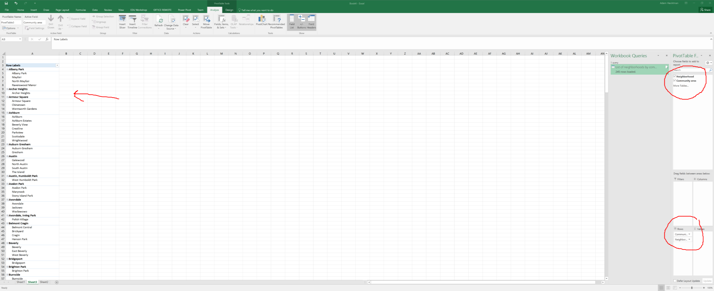

Analyzing Data

*Try using the filters by filtering to a department - for example, filter just the Aviation department.*

*Then clear the filter.*

*Take salary and format the entire column as $*

*You can use the Reduce the Decimal button so that it is only dollar values, no cents*

*In the empty column to the right of employee salary type a name first row - something like "New Salary"*

*In the first empty row (2) start typing "=" and then click on the column to the left.*

*Note that in the formula bar, instead of a cryptic row and column, it gives you a meaningful name*

*Now type \* 1.05 and hit enter.*

Machine generated alternative text:
UEL 
'HER 
Font 
=[@[employee_annual_salary]]*1.05 
job_titles 
WATER RATE TAKER 
POLICE OFFICER 
POLICE OFFICER 
CHIEF CONTRACT EXPEDITER 
CIVIL ENGINEER IV 
ASST TO THE ALDERMAN 
GENERAL LABORER - DSS 
TRAFFIC CONTROL AIDE-HOURLY 
STAFF ASST TO THE ALDERMAN 
Alignment 
department 
WATER MGMNT 
POLICE 
POLICE 
GENERAL SERVICES 
WATER MGMNT 
CITY COUNCIL 
STREETS & SAN 
OEMC 
cm COUNCIL 
Number 
New 
90,744 —[@[employee_annual_salaryll 
*1.05 
84,450 
84,450 
89,880 
106,836 
70,764 
41,850 
20,051 
49,452 

*Hit enter*

*You should have "=[@[Employee Annual Salary]]\*1.05" in the formula bar*

*Format as dollars by clicking $ on the toolbar.*

**Quick Analysis Tools**

*Click on a cell in the table*

*Ctl+Q to bring up the quick analysis tools*

*Hover over the data bars, the color scale, the icons*

*Choose Data Bars and note how they provide a visualization within the cell*

Machine generated alternative text:
Font 
job_titles 
WATER RATE TAKER 
POLICE OFFICER 
POLICE OFFICER 
CHIEF CONTRACT EXPEDITER 
CIVIL ENGINEER IV 
ASST TO THE ALDERMAN 
GENERAL LABORER - DSS 
TRAFFIC CONTROL AIDE-HOURLY 
STAFF ASST TO THE ALDERMAN 
ELECTRICAL MECHANIC 
FIRE ENGINEER-EMT 
105,336 
POLICE OFFICER 
FOSTER GRANDPARENT 
CLERK Ill 
INVESTIGATOR - 'PRA Il 
POLICE OFFICER 
POLICE OFFICER 
FIREFIGHTER (PER ARBITRATORS AWARD) 
POLICE OFFICER 
FIREFIGHTER/PARAMEDIC 
ENGINEERING TECHNICIAN VI 
FIREFIGHTER-EMT 
LIEUTENANT 
CROSSING GUARD 
Alignment 
-PARAMEDIC 
ELECTRICAL MECHANIC-AUTO-POLICE MTR MNT 
CIVIL ENGINEER Il 
GENERAL LABORER - DSS 
FOSTER GRANDPARENT 
POLICE OFFICER 
PARAMEDIC 
MOTOR TRUCK DRIVER 
LIBRARY ASSOCIATE- HOURLY 
POLICE OFFICER 
SENIOR PROGRAMMER/ANALYST 
CIVIL ENGINEER IV 
ENGINEERING TECHNICIAN V 
POLICE OFFICER 
SUPERVISING TRAFFIC CONTROL AIDE 
SANITATION LABORER 
POLICE OFFICER 
AMBULANCE COMMANDER 
POOL MOTOR TRUCK DRIVER 
FIREFIGHTER-EMT 
SEWER BRICKLAYER 
TREE TRIMMER 
TRAFFIC SIGNAL REPAIRMAN 
PERSONAL COMPUTER OPERATOR Ill 
SENIOR COMPANION 
department 
WATER MGMNT 
POLICE 
POLICE 
GENERAL SERVICES 
WATER MGMNT 
CITY COUNCIL 
STREETS & SAN 
OEMC 
cm COUNCIL 
AVIATION 
FIRE 
POLICE 
FAMILY & SUPPORT 
POLICE 
1 PRA 
POLICE 
POLICE 
FIRE 
POLICE 
FIRE 
WATER MGMNT 
FIRE 
FIRE 
OEMC 
GENERALSERVICES 
WATER MGMNT 
STREETS & SAN 
FAMILY & SUPPORT 
POLICE 
FIRE 
STREETS & SAN 
PUBLIC LIBRARY 
POLICE 
FAMILY & SUPPORT 
WATER MGMNT 
BUSINESS AFFAIRS 
POLICE 
OEMC 
STREETS & SAN 
POLICE 
FIRE 
STREETS & SAN 
FIRE 
WATER MGMNT 
STREETS & SAN 
TRANSPORTN 
HEALTH 
FAMILY & SUPPORT 
Number 
90,744 
84,450 
84,450 
89,880 
106,836 
70,764 
41,850 
20,051 
49,452 
93,600 
100,320 
90,618 
2,756 
46,896 
73,920 
74,028 
81,588 
99,228 
81,588 
88,596 
108,228 
92,682 
111,474 
17,846 
93,600 
58,536 
41,850 
2,756 
87,384 
70,380 
72,862 
25,334 
46,668 
106,836 
106,836 
98,616 
70,380 
59,652 
Fo rmattinq 
N ew salary 
95,281 
88,673 
88,673 
94,374 
112,178 
74,302 
43,942 
21,054 
51,925 
98,280 
95,149 
2,894 
49,241 
77,616 
77,729 
85,667 
104,189 
85,667 
93,026 
113,639 
97,316 
117,048 
18,739 
98,280 
61,463 
43,942 
2,894 
91,753 
73,899 
76,506 
26,601 
49,001 
Charts 
Data Bars 
Color... 
112,178 
112,178 
103,547 
73,899 
62,635 
Totals 
Icon Set 
Tables 
Greater... 
Sparklines 
Clear... 
Conditional Formatting 
2,756 $ 
uses rules to highlight interesting data. 
2,894 

*Click on a cell inside the table*

*Ctl+Q to bring up the quick analysis tools*

*Try Data Bars*

*Try icons*

**Sparklines**

*Open the Sparklines for Housing Centers workbook*

*Click on the Insert tab on the ribbon*

*Click on Line*

*Select the range of numbers for the data range*

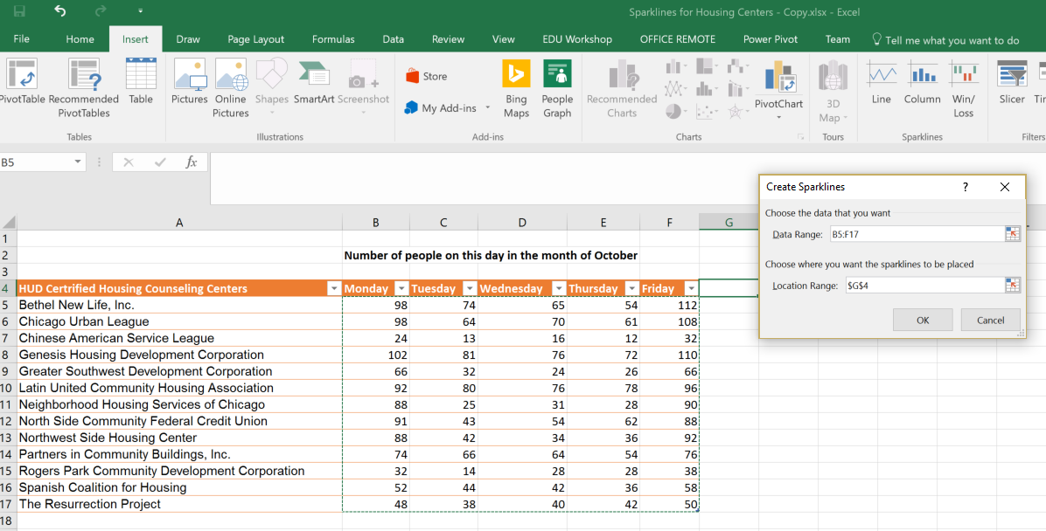

*And the corresponding area in column G for the location range (in this one, it is G5:G17)*

*Make the column with the sparklines wider*

*In the Show section, check High Point and Low Point*

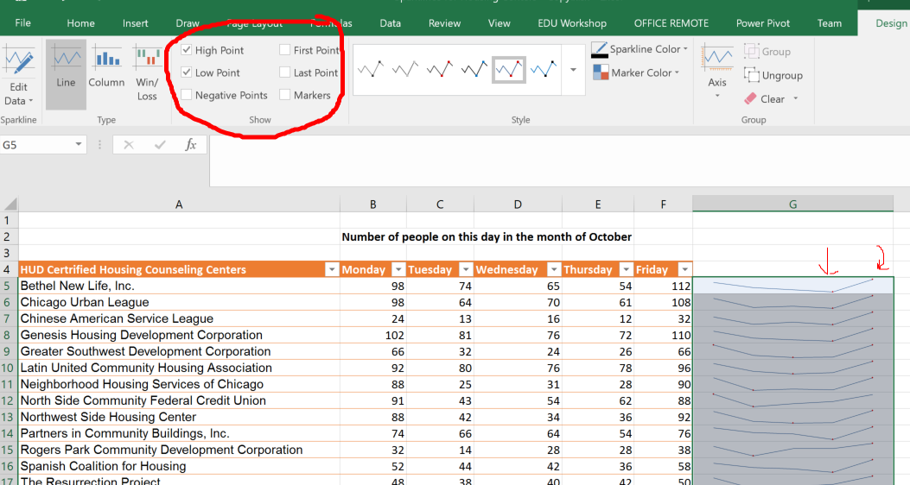

*Click on the Marker Color*

*Choose a separate color for the High Point and the Low Point*

*Change the numbers in row 5 (Bethel New Life in the example) to be single digit numbers like 1, 2, 3, 4,5.*

*Click on the Design tab*

*Click on the arrow under Axis*

*Change both the Vertical Axis Minimum and Maximum to be the Same for All Sparklines*

*Click on Column in the Type section of the Design tab.*

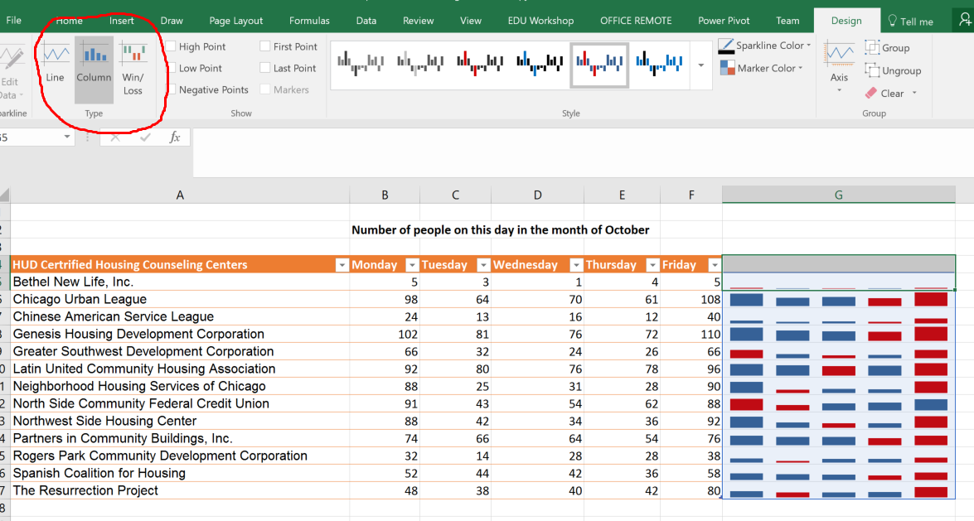

*Close the Sparklines for Housing Centers workbook*

Hierarchy Charts

*Open Clients Served in 2016 workbook*

*Select some or all of the Community areas, neighborhoods, and the data.*

*You must also select the column headings*

*Click on Insert, and choose the Hierarchy Charts from the Charts section.*

*Choose a Treemap*

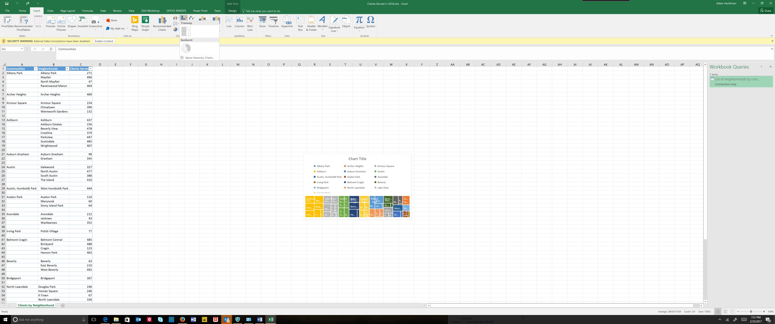

*Expand the Treemap so that you can easily see the individual blocks.*

*Explore the different designs*

*Add a chart title.*

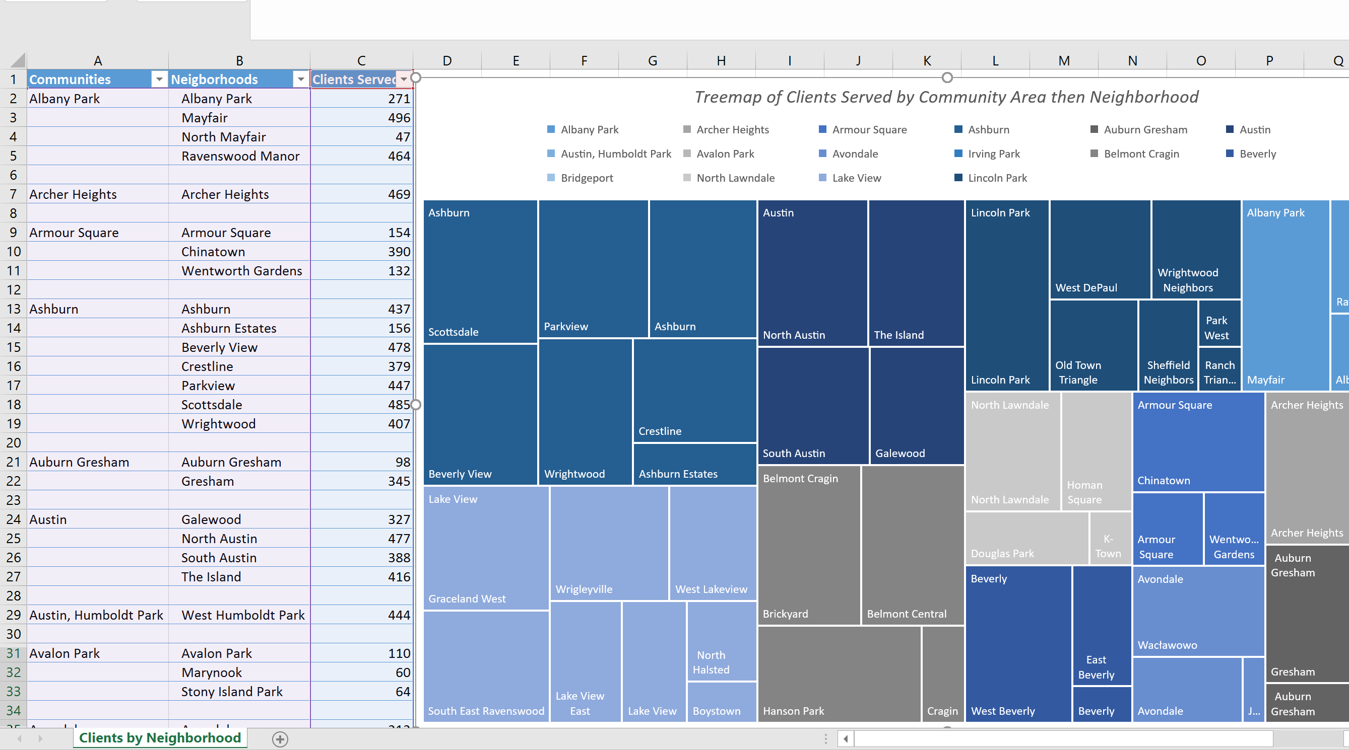

*Click on Change Chart Type*

*Click on Sunburst*

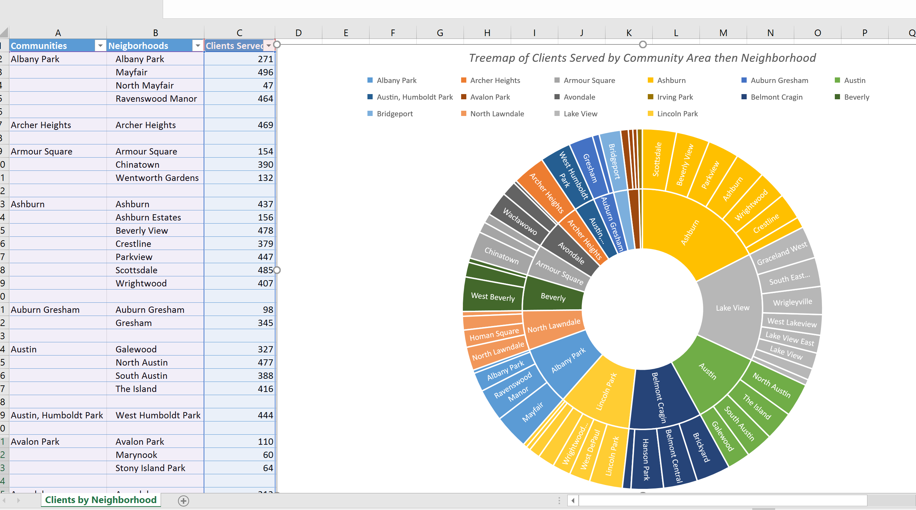

*Close the workbook*

Mapping Data

**Note for student**: For this one, if you are not using my sample data sets, you should have a data set already downloaded. I used the Chicago 311 Graffiti Requests dataset.

It needs to have a column that connotes time (such as creation date) and location columns (such as Latitude and Longitudes)

*Open the data set.*

Machine generated alternative text:
Formatted - Excel 
Normal 
Check Cell 
Neutral 
Linked Cell 
Calculation 
Note 
Conditional Format as 
Formatting • Table • 
Light 
Medium 
Bad 
Explanatory 
Input 
- 
- 
Dark 
New Table Style... 
New PivotTable Style... 
- 
- 

*This is a good place to try filters and sort options, like:*

* + *Filtering multiple values*
  + *Searching in the filter search box for values to filter*
  + *Sorting by various criteria*
  + *Etc.*

*On the left, click in the Table Name box and replace Table1 with Graffiti (or whatever your data set is)*

Machine generated alternative text:
Removal.xlsx - Excel 
Draw 
Page Layout 
Table Name 
Table 1 
•3 Resize Table 
Creation Date— Status 
FormuLæ 
nsert 
Slicer 
Properties 
Open in Browser 
Ref resh 
Unlink 
Zble Data 
Power Pivot 
HeaderRo..v 
I Row 
Banded Rows 
Team 
First Column 
Last Column 
nded Columns 
Style Options 
Tell me what you want to do 
Filter Button 
Summarize with PivotTable 
Remove Duplicates 
Convert to Range 
Export 
Zble Styles 
2746 W 50TH ST 
Completion Date— Service Request Numbe— Type of Service Reques— What Type of Surface is the Graffiti on — Where is the Graffiti locate* Street Address— ZIP Code— X Coordinate' Y Coordinate— Ward 
Police Distric— Community Area— SSA 
Latitude. Longitude. 
3 
3/3/2016 completed 
3/3/2016 completed 
3/3/2016 completed 
3/3/2016 completed 
3/3/2016 completed 
3/3/2016 completed 
3/3/2016 completed 
3/3/2016 completed 
3/3/2016 completed 
3/3/2016 completed 
3/3/2016 completed 
3/3/2016 completed 
3/3/2016 completed 
3/3/2016 16-01292850 
3/3/2016 16-01290692 
3/3/2016 16-01293583 
3/3/2016 16-01290517 
3/3/2016 16-01290723 
3/3/2016 16-01290510 
3/3/2016 16-01290515 
3/3/2016 16-01287321 
3/3/2016 16-01290677 
3/3/2016 16-01290543 
3/3/2016 16-01290534 
3/3/2016 16-01290525 
3/3/2016 16-01290547 
Graffiti Remova I 
Graffiti Remova I 
Graffiti Removal 
Graffiti Remova I 
Graffiti Removal 
Graffiti Remova I 
Graffiti Removal 
Graffiti Remova I 
Graffiti Removal 
Graffiti Remova I 
Graffiti Removal 
Graffiti Remova I 
Graffiti Remova I 
Metal- Painted 
Brick - unpainted 
Other / unknown Surface 
Metal - unpainted 
Brick - Painted 
Brick - Painted 
Brick - unpainted 
Wood - unpainted 
Brick - Painted 
Brick - Painted 
Metal - Painted 
Metal 
unpainted 
Garbage Cart 
Front 
Mail Box 
847 W BELMONT 
4401 W DIVISION 
5819 W FULLERTC 
1640 W 34TH ST 
5306 S PULASKI R 
2155 W 21ST PL 
2059 W 19TH ST 
2751 W BLOOMI,' 
1132 N MONITOF 
1016 W CULLERT( 
1165 W 18TH ST 
2100 W 19TH ST 
1636 W 34TH ST 
60651 
60639 
60632 
60608 
60647 
60651 
1169936.596 
1146814.312 
1137104.706 
1165855.68 
1150602.188 
1162330.344 
1162942.02 
1157652.986 
1137151.089 
169815.28 
168890.38 
1162672.82 
1165874.98 
1921450.184 
1907631.165 
1915356.767 
1882192.302 
1869112.07 
1889714.362 
1890732.481 
1911864.17 
1906949.595 
1890583.17 
1891562.497 
1890726.081 
1882192.702 
17 41.93985 
41.9024 
41.92378 
41.83243 
41.79659 
41.85292 
41.85569 
41.9138 
41.90122 
41.85537 
41.85785 
41.85592 
41.83243 
-87.651105 
-87.736264 
-87.771732 
-87.667232 
-87.723404 
-87.680488 
-87.678275 
-87.696717 
-87.771842 
-87.652191 
-87.655761 
-87.678512 
-87.667075 

*Click 3D Map from the Insert tab*

Machine generated alternative text:
Text 
Insert 
Legend 
Time Date & 
Line Time 
Time 
our 
Editor 
Layer 
Pane 
View 
Field 
Field List 
Drag fields to the Layer Pane. 
Completion Date 
Creation Date 
Latitude 
Longitude 
Police District 
Service Request Number 
SSA 
Status 
Street Address 
Type of Seo/ice Request 
What Type of Surface is the Graffiti o... 
Where is the Graffiti located? 
Add Layer 
Layer 1 
Location 
Add Field 
Height 
Add Field 
Category 
Add Field 
Time 
Add Field 
Filters 
Layer Options 

**Layers**

*In the Location box of the Layer options, choose +Add Field, and add Latitude and Longitude*

Machine generated alternative text:
Zield List 
Drag fields to the Layer Pane. 
Completion Date 
Creation Date 
Latitude 
Longitude 
Police District 
Service Request Number 
SSA 
Status 
Street Address 
Type of Seo/ice Request 
What Type of Surface is the Graffiti o... 
Add Layer 
Layer 1 
Location 
O 
Latitude 
O 
GDngitude 
Add Field 
Height 
Add Field 
Select One.„ 
Select One.„ 

*Where it says "select one", choose latitude and longitude respectively. If there are other fields that automatically came up in your location box, you can delete them by clicking on the X on the right.*

*Under Height, click + Add Field and choose Service Request Number. It will default to Count .*

*Under Category, click + Add Field and choose Where is the graffiti located.*

Machine generated alternative text:


*Click on the pencil and rename the layer to "Graffiti by Location"*

*Zoom in using the mouse wheel or using the + and - buttons*

*Tilt up and down using the arrows*

*Generally explore the map with the audience*

*Click on the Layer Options and reduce the thickness of the column to something around 50% (you can see it change in real time so you will know what makes sense for your visualization).*

Machine generated alternative text:
x 
.47- 
Express Way Job 
Fence 
Front 
Garage 
Garbage Cart 
Hydrant 
Mail Box 
Newspaper Box 
Overpass 
Phone 
Pole 
Rear 
Side 
Sign 
Traffic Control Box 
Viaduct 
Add Field 
Height 
Service Request Number (Count - Not...' 
Add Field 
Category 
Where is the Graffiti located? 
Time 
Add Field 
Layer Options 
Height 
Thic kness 
Guk current scale 
Opacity 
Show Values 
Zeroes 
Negatives 
Nulls 
Data Card 
Custom ize 

*On the toolbar, click on Map Labels. This will go to Bing Maps and pull in the labels and put them on your map. It is important to do this for viewers who may not know your city as well as you do.*

**Scenes**

*In the Layer Pane, choose Time and + Add Field. Choose creation date. If there is a lot of data, this may take a bit. You will see the status bar on the bottom left say "Processing…"*

Machine generated alternative text:
Add Layer 
Graffiti By Location 
Location 
@ Latitude 
O 
GDngitude 
Add Field 
Height 
Latitude 
Longitude 
Service Request Number (Count - 
Add Field 
Category 
Where is the Graffiti located? 
Time 
Add Field 
Tablel 
Completion Date 
Creation Date 
Not...' 
x 

*Note the Media Strip*

Machine generated alternative text:
ell 

*If you click the "play" button, you will see this data grow over time.*

*Right click on the time box on the upper left and change the format to show just days, or months depending on your data set.*

*Next click on Scene Options and experiment with the various transition effects*.

*Click on the Play Tour button from the toolbar.*

*Click Add Layer to the Layer pane and give this new layer a name*

*Hide the first layer by clicking on the eye so that you can focus on this new layer*

*Use a heat map for this layer*

*Assign the location to Zip Code (or, if your dataset does not have Zip, use some other geography larger in scope than lat/long) and map it to Postal Code*

*Choose Service Request Number (Count) for the Value*

*Choose Creation Date for the time*

*Experiment with Layer Options, showing the impact directly on the map*

Machine generated alternative text:
Add Layer 
Graffiti By Zip 
Location 
@ ZIP Code 
Add Field 
Value 
Postal Code 
Graffiti By Zip 
Service Request Number (Count - Not Blank) 
or Less 
Not...' 
80,686m 
or More 
Lyo s 
Forest View - 
Service Request Number (Count - 
Add Field 
Time 
Creation Date (None) 
Filters 
Layer Options 
Color Scale 
Radius of Influence 
Guk current scale 
Opacity 
Visual Aggregation 
Default 
Colors 
Show Values 
Zeroes 
Negatives 
Nulls 
Data Card 
Custom ize 
C h i c a 90 
Midway 
Airport 
earing 

*Create a scene that shows the heat map alone by Hiding Graffiti by Location and give the scene a meaningful name*

Machine generated alternative text:
Play 
Tour • 
Create Capture 
Video Screen 
Tour 
New 
Scene • 
Themes 
Scene 
cene 
Refresh 
Shapes 
Layer 
Scene Options 
Map 
Tour 1 
Requests by Zip 
o (10 sec) 
Scene duration (sec) 
Scene Name 
Requests by Zip 
Effects 
Transition duration (sec) 
Flat Find Custom 
Map Location Regions 
Map 
10.00 
3m 
Effect 
Effect Speed 
Time 
Start date 
End date 
Speed 
Map Type 
Change 
Circle 
5/26/2004 AM 
3/3/2016 AM 

*Create a second scene by clicking on the New Scene button at the toolbar and chose to make a copy of the first*

*Change this scene so that it hides the Heat Map and shows the Requests by Location*

|  |  |
| --- | --- |
| Machine generated alternative text: Tour  Tour 1  Requests by Zip  2  Requests by Locati  Scene  0(10 sec)  Layer  Scene Options  Scene duration (sec)  Scene Name  Requests by Location  Effects  Transition duration (sec)  Ions  Map  10.00  3m  Circle  Effect  Effect Speed  Time  Start date  End date  Speed  Map Type  Change  5/26/2004 AM  3/3/2016 AM | Machine generated alternative text: Add Layer  > Graffiti By Location |

*If you like, create a third scene with the two together.*

**Tours**

*Click Play the tour*

*Click create video*

*If you have music you can use, click Use Soundtrack and add it*

*If you decide to actually go ahead and make the movie, choose a low res option so that it doesn't take a long time*

Transforming data

*Open Address.xlsx or your own dataset that contains addresses*

*First, make some space by creating 5 columns next to the address. You can name them Block, Address, Direction, Street, and Suffix. The "Block" column will contain the block-level address (e.g. the 1600 Block vs. the 1612 Address).*

*From the Data tab on the toolbar, choose Text to Columns*

*In this case, we will choose Delimited and next.*

*Now we tell Excel what character is the delimiter. Notice that we can preview what the data will look like when we are finished.*

*Check "Space" and click Next.*

Machine generated alternative text:
suffix 
Address2 
3825 W 63RD ST 
1351 W ADDISON ST 
2222 ARCHER AVE 
City State 
CHICAGO 
CHICAGO 
CHICAGO 
60629 
60613 
60616 
Convert Text to Columns Wizard Step 2 of 3 
This screen lets you set the delimiters your data contains. You can see hcn,v your text is affected 
in the preview below. 
Delimiters 
z Tab 
Semicolon 
Comma 
Z] Space 
Other: 
Data preview 
Treat consecutive delimiters as one 
Text qualifier: 
Finish 

*For destination, either select columns that you want to put the data into with the Wizard collapsed, or simply type in the name of the range. We want to start breaking things up and placing them starting with Address, so it will look like this:*

Machine generated alternative text:
to 
Columns 
Address 
Reapply 
Advan ced 
Street 
Flash 
suffix 
Remove 
Duplicates 
Consolidate 
Data 
Relationsh ips Manage 
Data Model 
City State 
What-If 
Analysis • 
Forecast 
Sheet 
Sort & Filter 
Direction 
Validation • 
Data Tools 
Address2 
13825 W 63RD ST 
11351 W ADDISON ST 
12222 ARCHER AVE 
Convert Text to Columns Wizard - Step of 3 
{4635 W 63RD ST 
14759 W FULLERTON AVE 
14820 W Walton st. 
17242 W TOUHY AVE 
1159 N WABASH AVE 
15600 W FULLERTON AVE 
111718 S WESTERN AVE 
5010 W CHICAGO AVE 
14359 N PULASKI RD 
CHICAGO 
CHICAGO 
CHICAGO 
chicago 
CHICAGO 
CHICAGO 
CHICAGO 
CHICAGO 
CHICAGO 
CHICAGO 
CHICAGO 
CHICAGO 
Forecast 
Zip Inspec 
60629 
60613 
60616 
628 
60629 
60639 
60651 
60631 
60601 
60639 
60643 
60651 
60641 

*Click Finish and it should look like this:*

Machine generated alternative text:
Block 
Address 
Direction 
3825 w 
1351 w 
2222 ARCHER 
11147 s 
46 E 
11334 s 
4635 w 
4759 w 
4820 w 
7242 w 
159 N 
5600 w 
11718 s 
5010 w 
4359 N 
Street 
63RD 
ADDISON 
AVE 
MICHIGAN 
CHICAGO 
MICHIGAN 
63RD 
FULLERTON 
Walton 
TOUHY 
WABASH 
FULLERTON 
WESTERN 
CHICAGO 
PULASKI 
suffix 
AVE 
AVE 
AVE 
AVE 
AVE 
AVE 
AVE 
AVE 
AVE 
Address2 
3825 W 63RD ST 
1351 W ADDISON ST 
2222 ARCHER AVE 
11147 S MICHIGAN AVE 
46 E CHICAGO AVE 
11334 S MICHIGAN AVE 
4635 W 63RD ST 
4759 W FULLERTON AVE 
4820 W Walton st. 
7242 W TOUHY AVE 
159 N WABASH AVE 
5600 W FULLERTON AVE 
11718 S WESTERN AVE 
5010 W CHICAGO AVE 
4359 N PULASKI RD 
City State 
CHICAGO 
CHICAGO 
CHICAGO 
CHICAGO 
CHICAGO 
CHICAGO 
chicago 
CHICAGO 
CHICAGO 
CHICAGO 
CHICAGO 
CHICAGO 
CHICAGO 
CHICAGO 
CHICAGO 
Zip 

*Click on the function button and then type in plain language what it is you are looking for.*

*For example, type Round in the search for function, then G*o

Machine generated alternative text:
Connections 
ATI 
Get & Transform 
Insert Function 
Search for a function: 
ypeab 
lick Gol 
Or selecta category: Most Recently Used 
Select a function: 
CT 
MID 
YEAR 
SUM 
AVERAGE 
RO U ND DOWN (num 
Rounds a number down, tm,vard zero. 
Helo on this function 
U8MAN YOUTH MINISTRI 
Daycare (2- 6 Years) Risk 1 (High) 

*Select ROUNDDOWN.*

Machine generated alternative text:
Block 
[@Address]) 
Address 
Direction 
3825 w 
1351 w 
Street 
63RD 
ADDISON 
2222 AR 
11147 s 
46 E 
11334 s 
4635 w 
4759 w 
4820 w 
7242 w 
159 
N 
5600 w 
Function Arguments 
ROUND 
Num ber 
Num digits 
suffix 
[@Address] 
Address2 
3825 W 63RD ST 
1351 W ADDISON ST 
3825 
number 
Rounds a number to a specified number of digits. 
Number is the number you want to round. 
Formula result = 
Helo on this function 
CHICAGO IL 
CHICAGO IL 
Cancel 

*Select -2 for two decimal places to the left.*

*When you are done, the function will look like this: =RoundDown (B1,-2)*

*Notice that Excel predicted that you would want the entire column this way and executed a Flash Fill.*

Machine generated alternative text:
Add-ins 
Connections 
Properties 
Edit Links 
Connections 
h) 
h) 
h) 
h) 
h) 
h) 
h) 
h) 
h) 
h) 
h) 
h) 
h) 
dium) 
Power Pivot 
Address 
2200 
11100 
11300 
7200 
11700 
Tea m 
Filter 
Design 
Clear 
Reapply 
Adva nced 
Sort & Filter 
Direction 
3825 w 
1351 w 
2222 ARCHER 
11147 s 
46 E 
11334 s 
4635 w 
4759 w 
4820 w 
7242 w 
159 N 
5600 w 
11718 s 
5010 w 
4359 N 
Stree 
63RD 
ADDu 
AVE 
MICH 
CHIC' 
MICH 
63RD 
Wa Itc 
TOUP 
CHIC' 

*If you like, you can delete the address column.*

*Insert a column to the left of block. Call it Block Address*

*Put the cursor in the first empty row of Block Address (row 2)*

*Start typing in the formula bar =CONCATENATE*

*Notice that Autocomplete starts suggesting concatenate, and when you double click on it, you get a guide for how to use the function*

Machine generated alternative text:
Insert 
Draw 
Page Layout 
Formulas 
Add-ins 
Connections 
Properties 
Refresh 
Connections 
Power Pivot 
From 
From Other Existing 
Sources • Connections 
From Table 
Query • 
Recent Sources 
Get & r 
Get External Data 
DBA Name 
-CONCATENATE( 
Facility Typ 
rant 
Restaurant 
Restaurant 
Restaurant 
Restaurant 
Restaurant 
Restaurant 
Risk 
Risk 1 (High) 
Risk 1 (High) 
Risk 1 (High) 
Risk 1 (High) 
Risk 1 (High) 
Risk 1 (High) 
Risk 1 (High) 
Block Address Bloc 
-CONCATENATE( 
58GORDlTAS SANTIAGO 
5 D'AGOSTINOS PIZZA 
3 DOLO GARDEN RESTAURANT & BAR 
27 THE NEW RANCH STEAK HOUSE 
2 FLACO'S TACOS 
47 M & R FOODS 
KING'S CHOP SUEY 
Table 
Team 
Sort & Filter 
Addres: 
2200 
11100 
11300 

The function format is: = CONCATENATE(text, text, text).

*After the "(", click on the first Block address (F2 in the screenshot).*

*Note that @Block shows up. Then type ," " in order to insert a space*

*Click on Direction (H2) followed by ," ",*

*Click on Street (I2) followed by ," " ,*

*Click on Suffix and hit enter*

The full formula will be **=CONCATENATE([@Block]," ",[@Direction]," ",[@Street]," ", [@suffix])**

**Enabling the Add-in**

*In your spreadsheet, click File, Options, and choose Add-ins.*

*If you do not see the Analysis Tool Pack already in the list of add-ins, choose Excel-Add-ins from the Manage drop down in the bottom and hit Go*

Machine generated alternative text:
Excel Options 
General 
Formulas 
Proofing 
Language 
Advanced 
Customize Ribbon 
Quick Access Toolbar 
Add- ins 
Trust Center 
View and manage Microsoft Office Add-ins. 
Name 
Active Application Add-ins 
Analysis ToolPak 
Microsoft Power Map for Excel 
Microsoft Power Pivot for Excel 
Microsoft Power View for Excel 
Mindjet MindManager Add-In 
Team Foundation Add-in 
Inactive Application Add-ins 
Analysis ToolPak - VBA 
Date (XML) 
Euro Currency Tools 
Inquire 
Microsoft Actions Pane 3 
Solver Add-in 
Document Related Add-ins 
No Document Related Add-ins 
Disabled Application Add-ins 
No Disabled Application Add-ins 
Location 
Files\Microsoft 
Files\Microsoft Map Excel Add-inlEXCELPLUGINSHELL.DLL 
Files\Microsoft Excel Add-in\PowerPlvotExceICIientAddIn.dII 
Files\Microsoft View Excel Add-in\AdHocReportingExceICIient.dII 
16\Mm16ExceILinker.dII 
Files\Common Files\Microsoft Shared\Team Foundation 
Files\Microsoft 
Files\Common Files\Microsoft Shared\Smart TaglMOFL.DLL 
Files\Microsoft 
Files 
Files\Microsoft 
Excel Add- in 
COM Add-In 
COM Add-in 
COM Add-in 
COM Add-in 
COM Add-in 
Excel Add-in 
Action 
Excel Add-in 
COM Add-in 
XML Expansion Pack 
Excel Add-in 
Add-in: 
Publisher: 
ocation: 
Description: 
Analysis ToolPak 
Microsoft Corporation 
rmation available 
Files\Microsoft 
Provides data analysis tools for statistical an 
eering analysis 
Menage: Excel Add- ins 

*You will see a list of available add-ins. Check Analysis Tool Pack and click OK.*

*Now, when you click on the Data tab, you will see the Analysis Tool Pack.*

**Histogram**

*Somewhere in the spreadsheet, enter in separate rows on a column 1, 2, 3, 4, 5, 6. If you are using my sample spreadsheet, it is already there.*

Machine generated alternative text:
ΙΙΙ ΙΙΙ ΙΙΙΙΙΙΙΙΙΙΙΙΙ: 
ΙΙ ΙΙΙΙΙΙΙΙΙΙΙΙΙΙΙΙΕ 

*Now, go to the data tab, and click on Data Analysis Tools.*

*We will start with a simple histogram. Click Histogram and the following dialog box will appear:*

Machine generated alternative text:
Itnnnnnnnnnnnnł 

*Select column A for the range*

*Select your Bins for the Bin Range (including the label, assuming you have Labels checked)*

*Make sure you check the Labels checkbox (otherwise it will think your label is non-numeric data)*

*Keep the New Worksheet Ply as your output option (you can give it a name)*

*Click ok. That is all there is to it and it quickly analyzed a million rows and gave you the histogram*

Machine generated alternative text:
Bins 
4 
6 
More 
Frequency 
174599 
175019 
174558 
174817 
174853 
174729 
Histogram 
200000 
150000 
100000 
50000 
6 
• Frequency 
More 

**Sampling**

*Choose Data Analysis Tools from the Data tab*

*Choose Sampling.*

*Give it the input range (if you are using the die spreadsheet, make sure you check Labels).*

*Tell it how big your sample size should be in Number of Samples*

*Tell it where you want it to show the output*

Machine generated alternative text:
ΙΙΙΙΙΙΙΙΙΙΕ 
ΙΙΙΙΙΙΙΙΙΙΙΙΙΙΙΙΙ! 
ΙΙΙΙΙΙΙΙΙΙΙΙΙΙΙΙΙ: 
ΟΙ Z Z 
ο οοο 
ΙΧΙΙΙΙΙΙΙΙΙΙΙΕ 

**Descriptive Statistics**

*Choose Data Analysis Tools from the Data tab*

*Choose Descriptive Statistics.*

*Give it the input range (if you are using the die spreadsheet, make sure you check Labels).*

*For this example, have it group the data by column*

*Output the data to a New Worksheet Ply and give it a name*

*Check Summary Statistics*

*Check Confidence Level for Mean (you can keep it at 95%, which is standard)*

Machine generated alternative text:
Die Rolls 
41 
41 
31 
61 
31 
11 
41 
41 
61 
61 
31 
61 
51 
41 
3, 
31 
21 
Descriptive Statistics 
Input 
Input Range: 
Grouped By: 
Z] Labels in first rcn,v 
Output options 
C) Output Range: 
@ New Worksheet Ely: 
C) New Workbook 
Z] Summary statistics 
SA:SA 
@ Columns 
C) Rows 
Descriptive Stats 
Cancel 
Help 
Z] Confidence Level for Mean: 
Kth Largest: 
Kth Smallest: 

Machine generated alternative text:
Die Rolls 
Mean 
Standard Error 
Median 
Mode 
Standard Deviation 
Sample Variance 
Kurtosis 
Skewness 
Range 
Minimum 
Maximum 
Sum 
Count 
Confidence 
3.501661 
0.001667 
1.707169 
2.914426 
-1.26658 
-0.00178 
3671754 
1048575 
0.003268 